**Exp No:** 14 **Date:** 01/11/2020

**Name:** Swetha Saseendran

**Reg No:** 185001183

COVERSION OF BCD TO ASCII

## Aim:

To write an assembly language program to calculate the cube of an 8-bit number using an 8051 micro controller.

## Algorithm:

* Initialize R0 with 00h.
* Move the value in R1 to A.
* Move the value in R1 to B.
* Multiply A and B.
* Move the value in R1 to B.
* Multiply A and B.
* Move B to R4 (MSB of cube) and A to R5 (LSB of cube)

|  |  |
| --- | --- |
| Program | Comment |
| MOV R0, #00  MOV A, R1  MOV B, R1  MUL AB  MOV B, R1  MUL AB  MOV R5, A  MOV R4, B  **HERE:** SJMP HALT | R0 has address of 0x00  Transferring 8-bit number to reg A  Transferring 8-bit number to reg B  BA = A x B  B is empty since bit multiplication  Transfer 8-bit value to B  BA = A x B  Moving lower byte to R5  Moving higher byte to R4  Halt the program with a loop. |

# Snapshot of sample input and output:

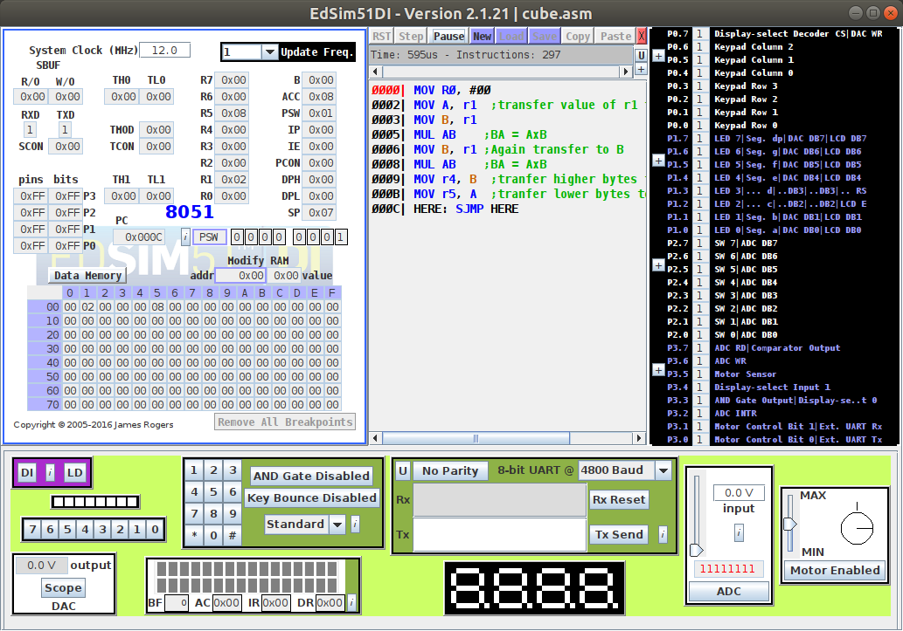

# Result:

An assembly level program was written to convert a given BCD value to its corresponding ASCII value using an 8051 microcontroller and the output was verified.